**Terraform Task-2**

**1) Watch the terraform-02 video.**

**Completed watching video**

**2) Execute all the templates shown in video..**

**a.**

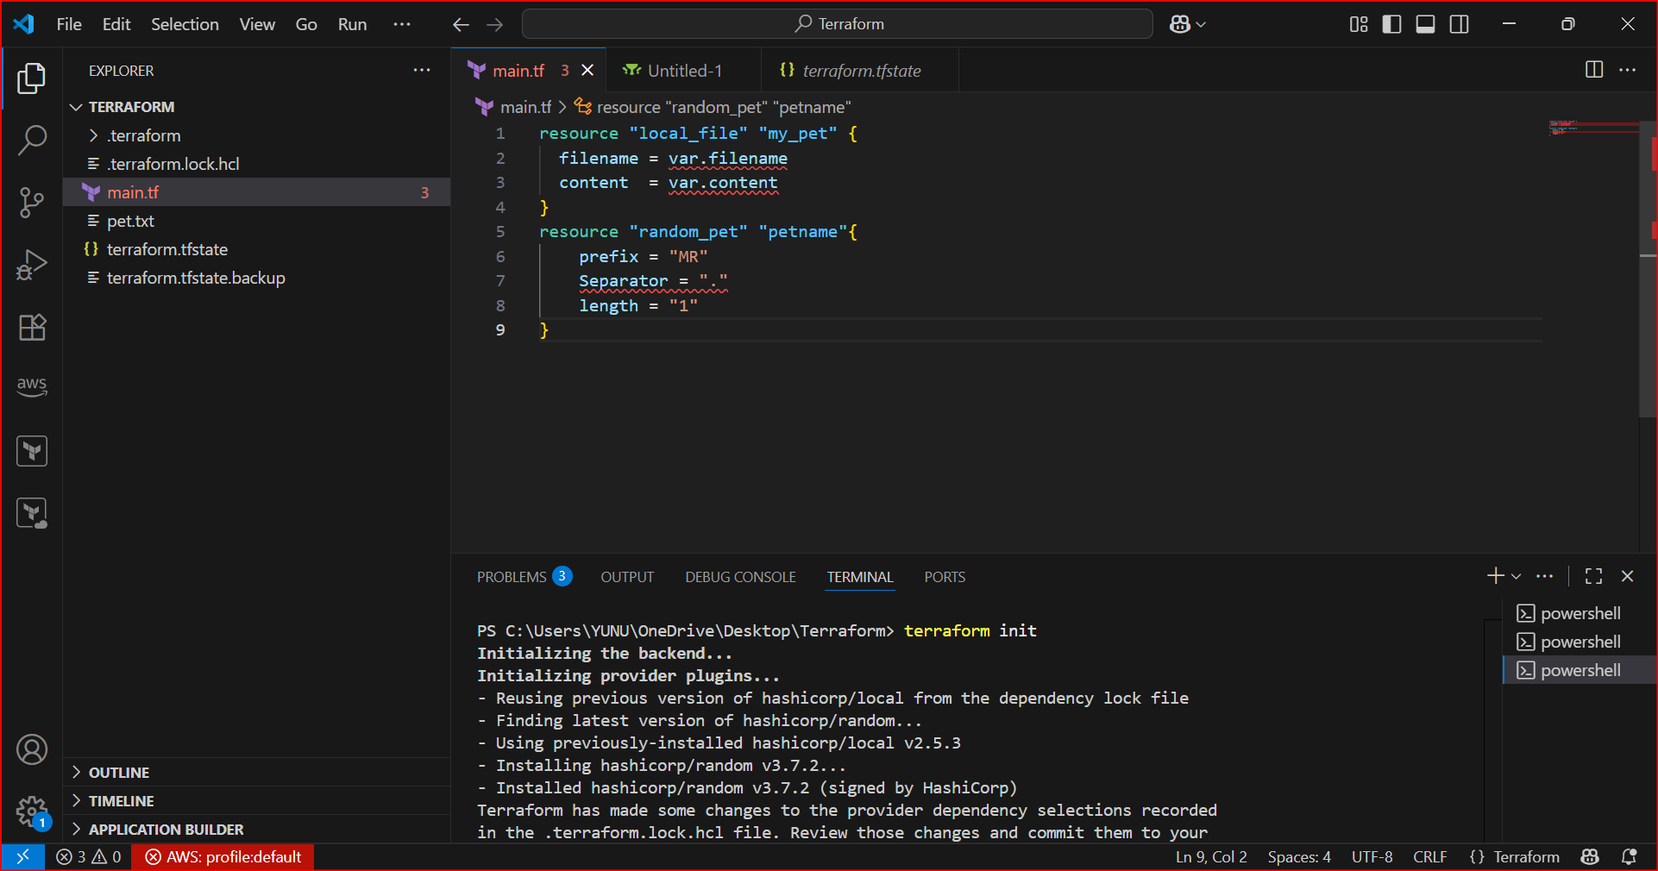

**If you have added new provider we need to initialized the init**

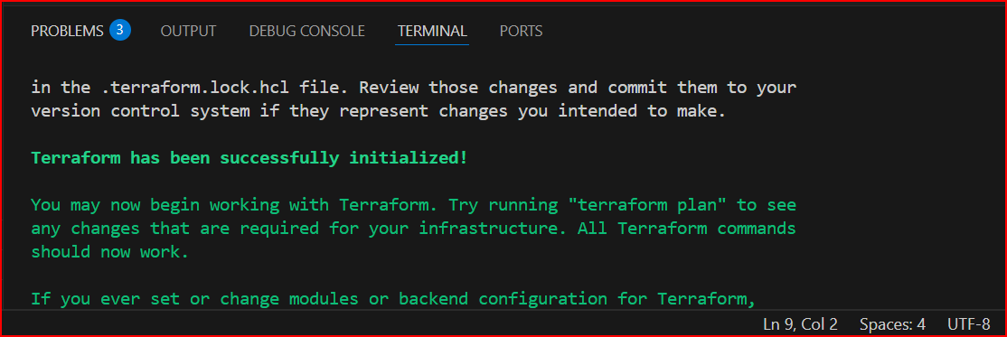

**b. There are there types of providers are avalible**

**1.official 🡪 provided by terraform**

**2.Partner 🡪 Provided by third party vendoers**

**3.community 🡪 Individual who can create.**

**c.** **I have deleted all the files excuting the terrafom init command**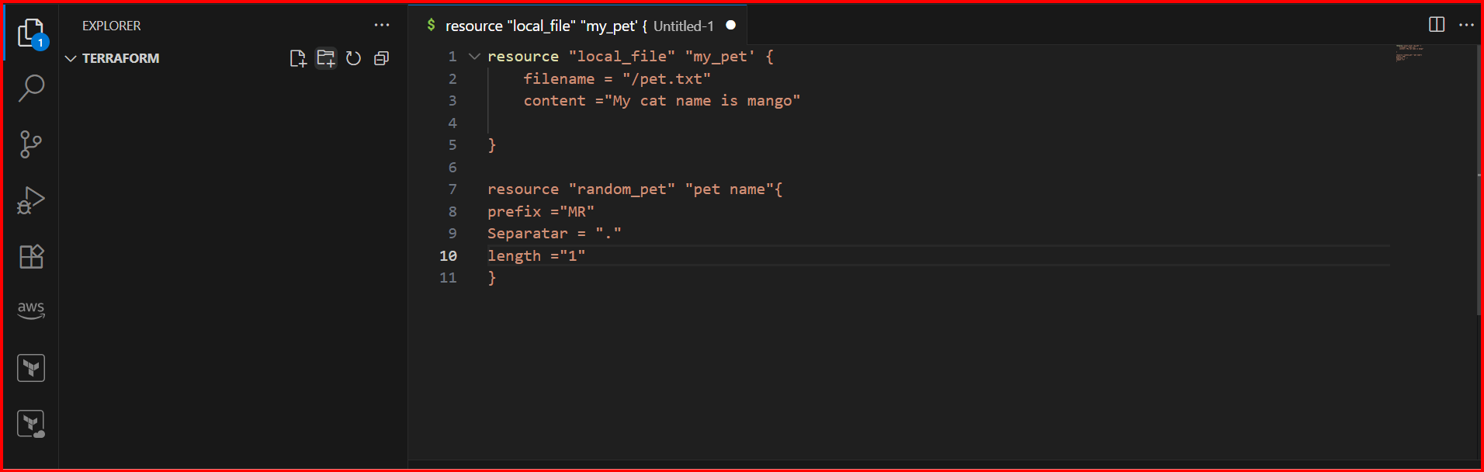

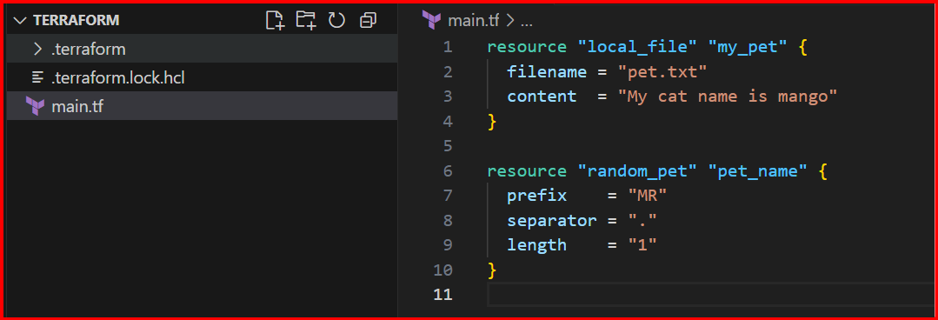

**Terraform apply**

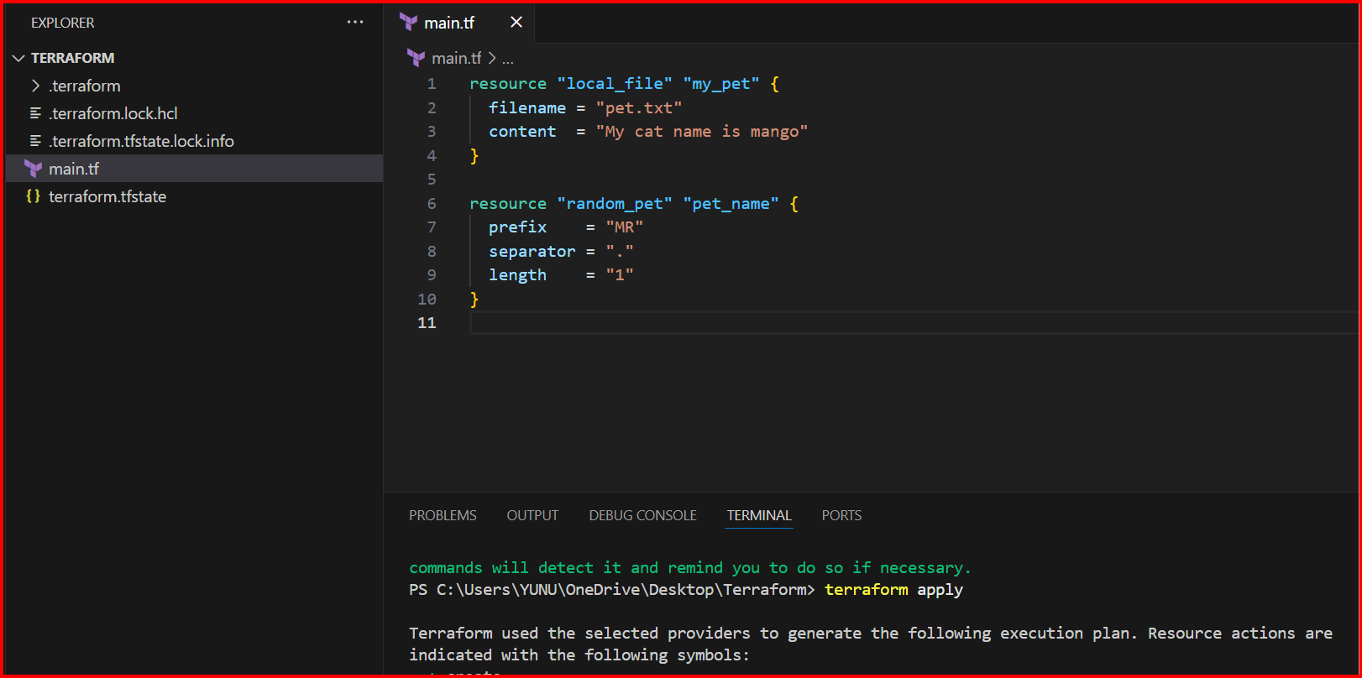

**e. Configuration Directory:**

**=======================**

**Main.tf -->main configuration file containing resource definition**

**variables.tf --> contains varibles declaration**

**output.tf --> contains outputs from resources**

**provider.tf --> contains the provider definition**

**f. If you modify anything in main.tf first it will destroy and then it will add (Immutable)**

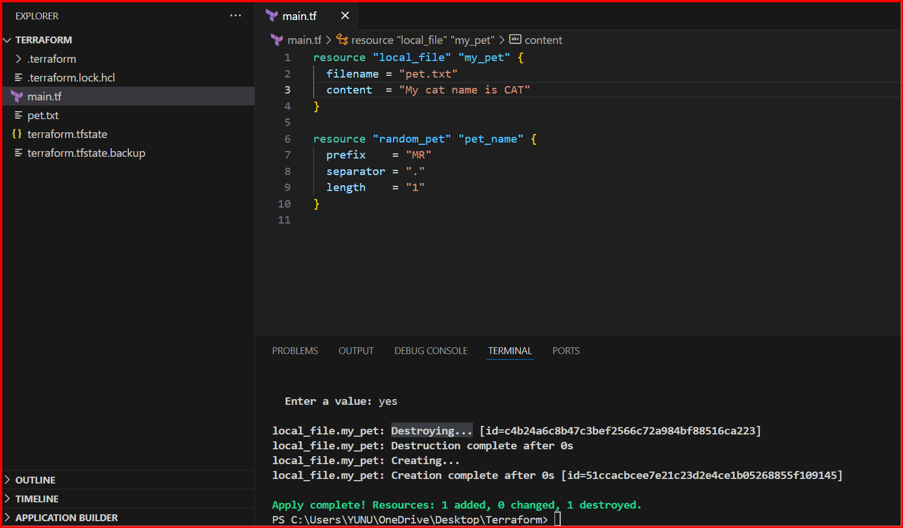

**Life cycle:**

1. **create_before_destroy**
2. **prevent_destory**
3. **ignore_changes**

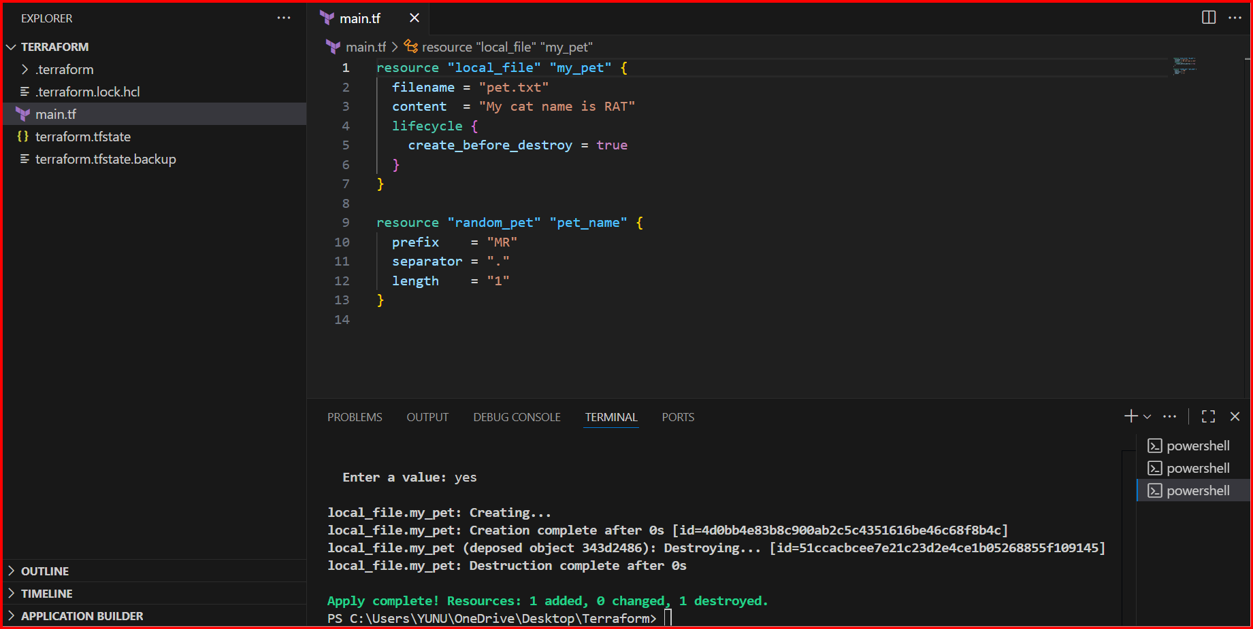

**First it will create and then destroy**

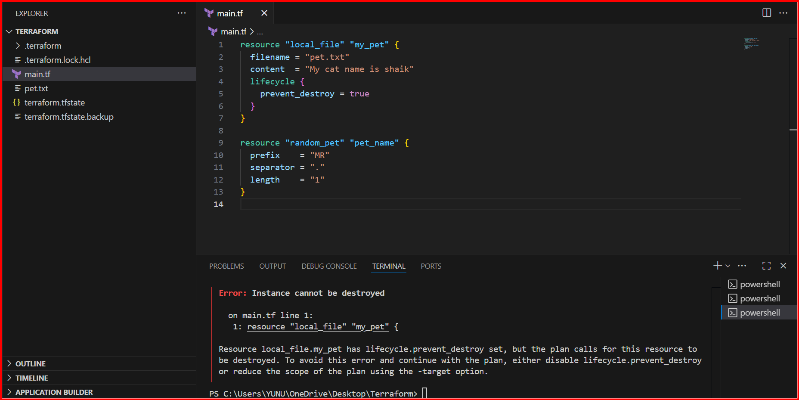

**Terraform will refuse to destroy that resource**

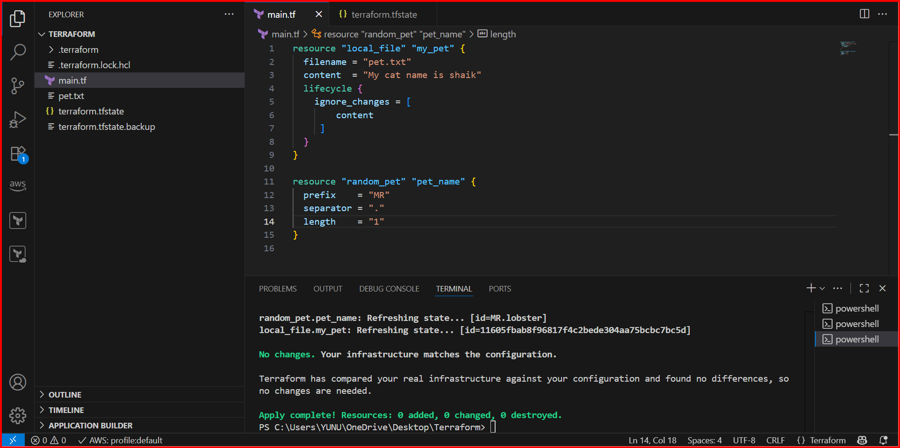

**If you change anything in .tf file it will not change in statefile.**

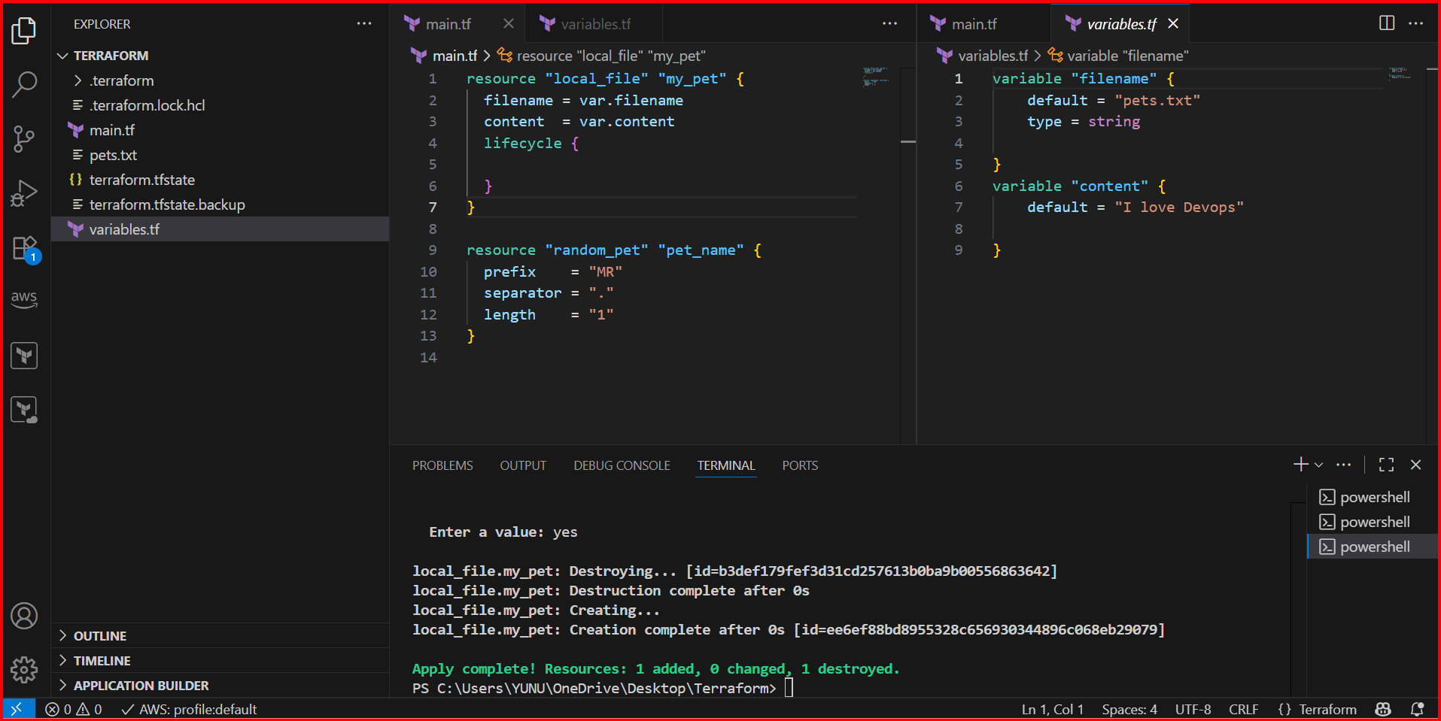

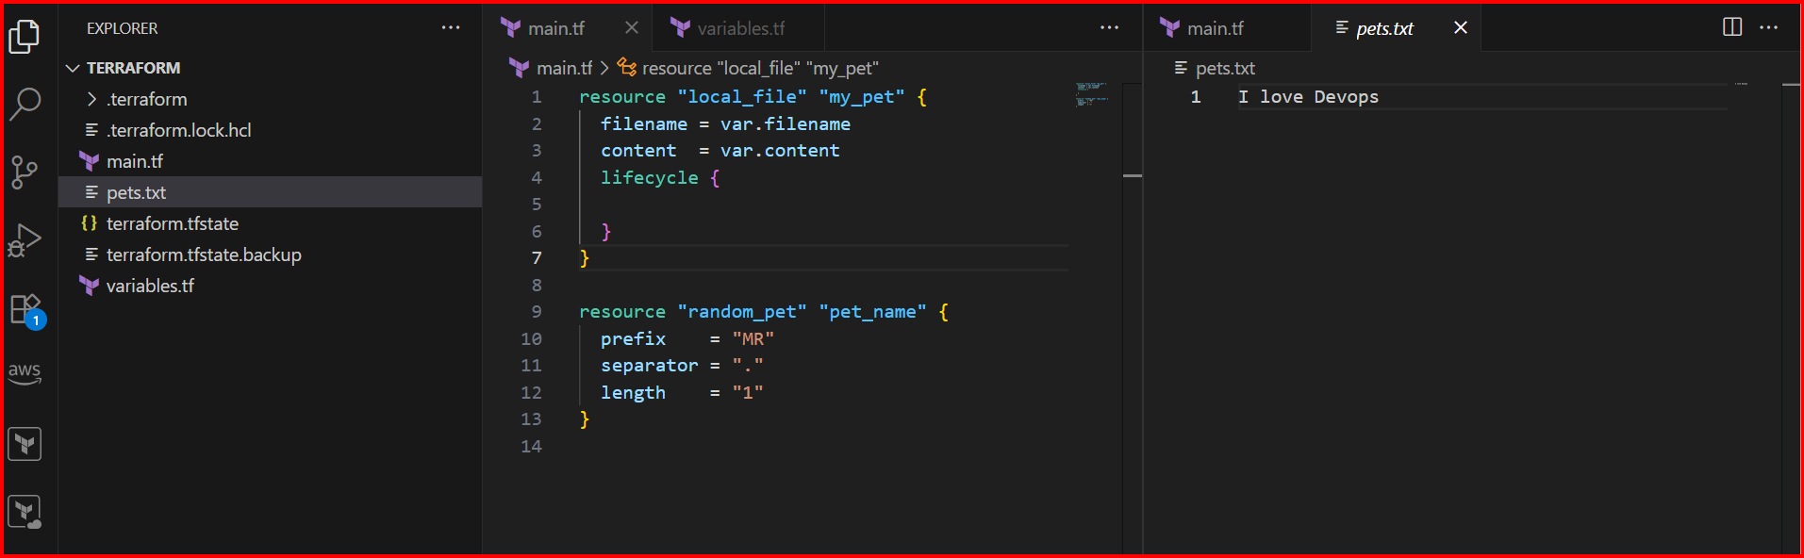

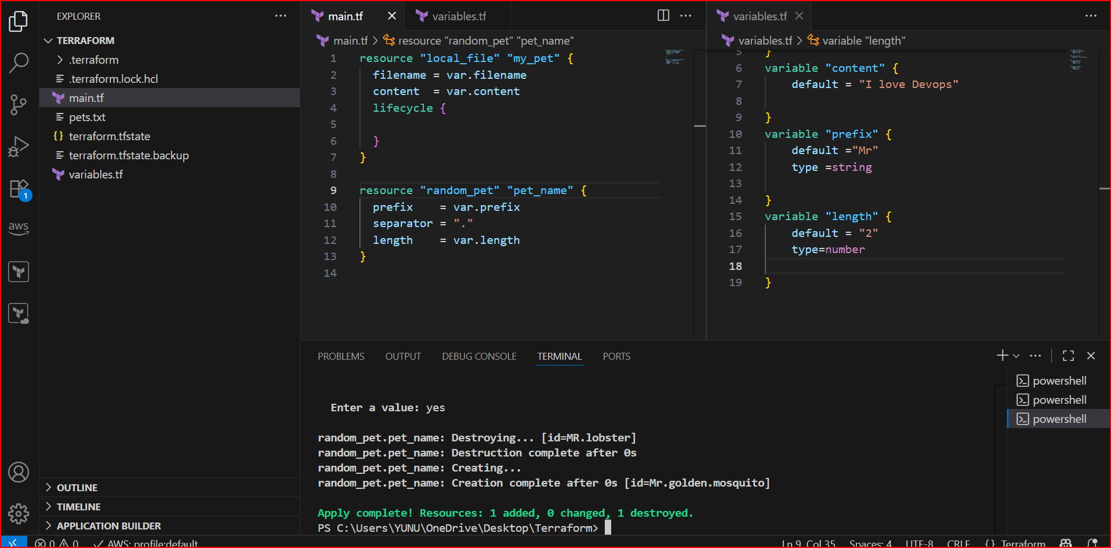

**Arrgument passed**

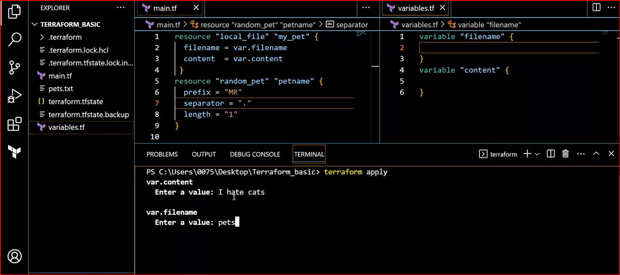

**3) Integrate terraform in Jenkins using Terraform plugin.**

**Install Jenkins**

**Install terraform plugin in Jenkins**

**Jenkins management 🡪 Tools 🡪 Configure the Terraform**

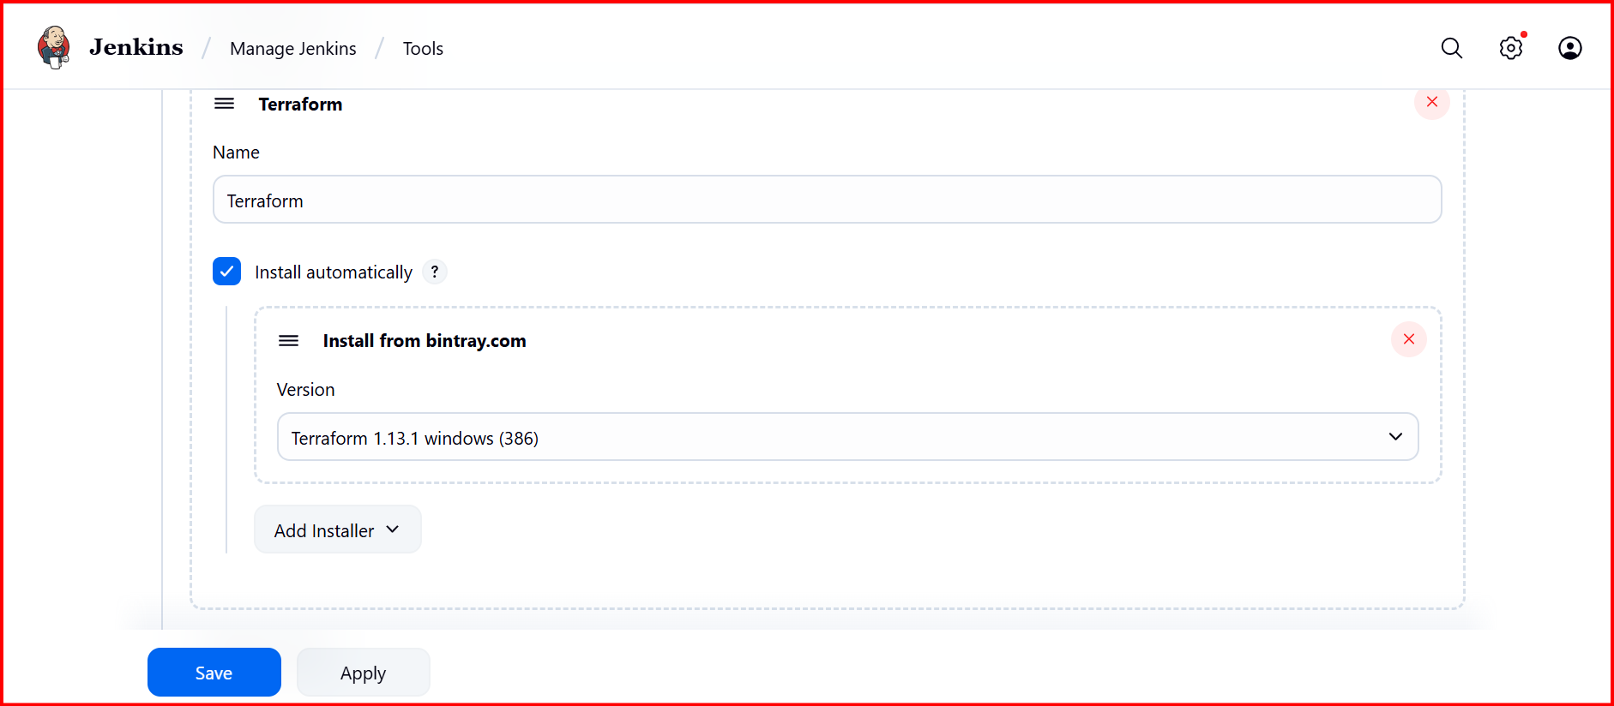

**Git repo :**

**main.tf**

**resource "local_file" "my_pet" {**

**filename = var.filename**

**content = var.content**

**}**

**resource "random_pet" "petname" {**

**prefix = "MR"**

**separator = "."**

**length = "1"**

**}**

**Variables.tf**

**variable "filename" {**

**default ="pets.txt"**

**description = "The name of the file to create"**

**type = string**

**}**

**variable "content" {**

**default ="I love cats"**

**description = "The content to put inside the file"**

**type = string**

**}**

